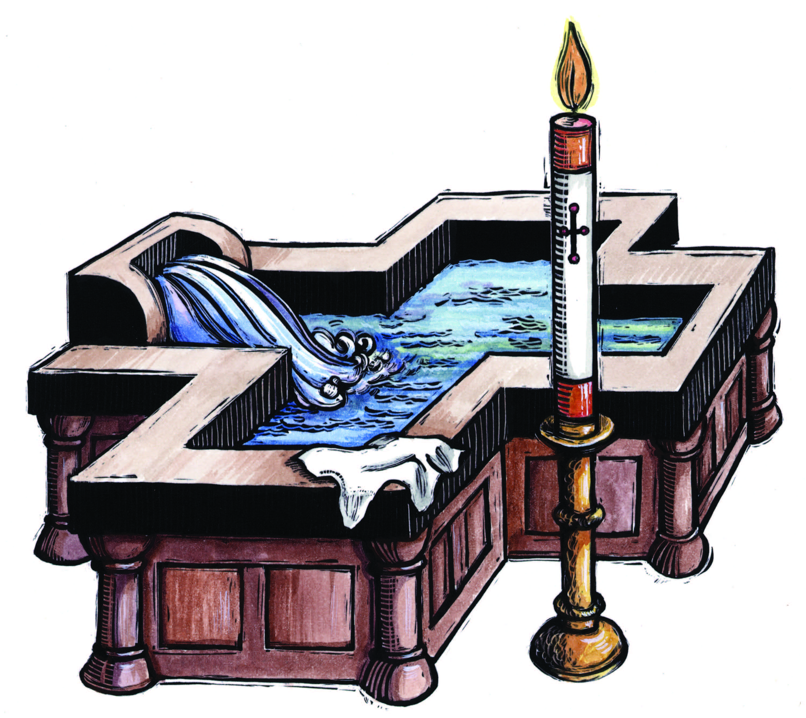
Saint Paul the apostle catholic parish
Parroquia Católica Romana de San Pablo del Apóstol
5508 Black Oak Lane River Oaks Texas 76114
817.738.9925

Congratulations in considering celebrating the Sacrament of Baptism to incorporate into the Family of God. We feel honored that you chose to baptize your child at Saint Paul the Apostle Catholic Church. Please carefully review the guidelines and contact information.

WHAT IS BAPTISM?
Baptism is a beginning. Baptism is the first of three sacraments of initiation in which a child is incorporated into Christ, becoming a new creation through water and the Holy Spirit. It is just the beginning of the lifelong journey of faith. Baptism is sealed by confirmation and completed in Eucharist.
After Baptism, it is the responsibility of the parents, in their gratitude to God and in fidelity to the duty they have undertaken, to enable the child to know God, whose adopted child it has become, to receive confirmation, and to participate in the Holy Eucharist. Introduction to the Rite of Baptism for Children

Infant Baptism is an Act of Worship. Like all sacraments, Baptism is an act of worship in which the whole church turns their hearts and minds and bodies toward God. Through the Rite of Baptism parents present their child for initiation into the Church. Together with the parish community, they offer praise and thanksgiving to God for the gift of salvation. They ask God to raise their child from the natural human condition to the dignity of an adopted son or daughter of God. By becoming one with Christ in Baptism, the child is freed from original sin and united with the Christian community.

Baptism is a Communal Event. Like all sacraments, Baptism belongs to the entire church. It is celebrated in the midst of the community as a sign that Baptism calls all of us to nurture and care for the child and to support the parents in their crucial task of handing on the faith.
Before and after the celebration of the sacrament, the child has a right to the love and help of the community….it is clear that the faith in which the children are baptized is not the private possession of the individual family but is the common treasure of the whole Church of Christ. Introduction to the Rite of Baptism for Children

Baptism Requires the Faith of Parents, Godparents and the Entire Church. For an infant to be baptized, it is necessary that:
- The parents or at least one of the parents’ consents to it, or the person who legitimately takes their place must consent.
- There is a founded hope that the child will be brought up in the Catholic religion; if such hope is lacking, the Baptism is to be delayed according to the precepts of particular law after the parents have been advised about the reason.
When and where is Baptism Celebrated? An infant should normally be BAPTIZED in the first few weeks or so following birth, with the following consideration: In setting the time for Baptism, the first consideration is the welfare of the child and that it is not deprived of the benefit of the sacrament. In danger of death the child should be baptized immediately. The second consideration is the health of the mother, so that if possible, she too may be present. When the health of the child is not a factor, another consideration is the readiness of the parents to accept the responsibility of bringing their child into the faith. Sometimes parents are not ready for the celebration of Baptism, or they ask for their child to be baptized, although the child will not afterward receive a Christian education and will even lose the faith. Since the rite itself does not allow enough time to resolve these dilemmas or train the parents in the faith, Baptism may be delayed until proper commitment and catechesis on the part of the parents is ascertained. This manual is applied to infant baptism only ranging from birth to completion of 8 years of age or per pastoral reason if the child has special need and over 8 years old. If your child is 8 years or older, please inquire about RCIA adapted for children.

In the case of adoption, a certificate issued by a United States’ court must be presented to verify that the adoption is formal, final and irrevocable. Parents and Godparents must ask themselves if they are ready to accept the responsibility of handling on the faith to their child since this task is charged primarily to them.

Thus, children should receive Baptism as soon as it’s practical after birth, taking into consideration the health of both the mother and child and the readiness of the parents and Godparents to accept the demands that Baptism places on them.

Baptisms should normally be celebrated in the parish of the infant’s parents; where they are registered. Because Baptism binds a child to the universal Church through a local community, at least one parent should be a registered, active member of Saint Paul the Apostle Catholic Church Community for at least six months prior to setting the date of Baptism. This means, at a minimum, regular participation in the Eucharist on Sundays and Holy Days of Obligation, regular celebration of the Sacrament of Reconciliation, financial and service-based support of the Church according to one’s abilities, and active participation in the apostolic work of the Church. If the parents wish to have their infant baptized at another Catholic Church other than their home parish, special reason with permission for Baptism from their pastor is required along with fulfillment of baptismal requirements.

Baptisms are generally celebrated at Saint Paul the Apostle Roman Catholic Church on the following schedule:
- By Group on the Fourth Sunday after the 8AM Community Mass in English.
- By Group on the Fourth Sunday after the 11AM Community Mass in Spanish.
- And only one family, at a first request first serve basis, at the community Mass on the Third Sunday at the 8AM Mass in English and 11AM Mass in Spanish. The child must be of age from birth till 8 months. The celebration will be immersion. Please inquire more detail about immersion with the receptionist.
- Baptism will not be celebrated from Ash Wednesday until the Easter Vigil in respect to the Season of Lent and the awaiting for the Season of Easter. Because of the Christmas season is busy, there will be no schedule baptism in the month of December.

How to Register and Prepare for Baptism? Please follow the procedure for registration and preparation for your child’s baptism:
- Parents must be registered and actively contributing to the parish for a minimum of 6 months and must reside within our parish boundaries. You can obtain information from the parish receptionist or secretary.
- Parents and godparents can inquire and prepare for Pre-baptismal instruction during the period of pregnancy and or after childbirth.
- Parents will have an obligatory review meeting with the pastor before taking the Pre-Baptismal Instruction to understand the requirement of baptizing the child according to the Catholic Faith tradition.
- Pick up this manual, read and register for Pre-Baptismal Catechesis at the parish office for parents and godparents living locally.
- Complete all Forms and provide a copy of the child’s birth certificate and necessary documents (Godparents sacramental records such as Baptism, Confirmation and First Eucharist and if married; a Church Marriage Certificate).
- A Pre-Baptismal Catechesis fee based on status of membership. Please inquire the office when register for Baptism in the office.
Naming the child: Traditionally, Catholic children are given a saint’s name. This is an outward sign that links the child to the communion of saints. Church law does not require that a child be given a saint’s name. It does, however, forbid a name that is offensive to Christians, our beliefs, or way of life.

Pre-Baptismal Catechesis for Parents and Godparents: In order for parents and the parish community to celebrate fully, careful planning and thoughtful preparation is needed. First-time parents and those who last had a child baptized three or more years ago are expected to participate in Infant Baptismal Catechesis scheduled by the Baptismal Ministry Team. These sessions include discussion about the meaning of Baptism, the signs and symbols used in the Rite of Baptism, and conversation about the responsibilities of parents and Godparents in teaching the faith. Both parents and Godparents are expected to attend. Here is the general outline of sessions and topics that must be complete, and a certificate will be issued and be eligible for 2 years:
- Must complete 2 Baptismal Catechesis sessions given in the span of months according to the calendar above:
Baptismal Preparation calendar as follow:

English ESPANOL
2nd Monday 7PM – 9:00PM 2nd Lunes 7PM – 9:00PM

Of the following months/de las meses siguen:
January, March, June, August, October, and November
Enero, Marzo, Junio, Agosto, Octubre, y Noviembre

Locations/Lugares:
English & Spanish: St. Paul Catechesis Building Room A
- Both English Pre-Baptismal Catechesis and Spanish Pre-Baptismal Catechesis will be conducted at St. Paul Catechesis Building. One session will be in the Church for the Rite and will be informed by the team.
- You may enter the catechesis at any beginning session of the month but will be required to complete within two months.
- The topics of Pre-Baptismal Catechesis are as follows:
Courses and Contents
- Registration – Given Handouts (Awaiting the Birth & Baptism Is a Gift & Choosing Godparents in the Roman Catholic Church)
- Session I – The Dignity of the Human Person
    - Awaiting the Birth of Your Child
    - Baptism Is a Gift
      - Handouts: The Signs of Baptism & Rite of Baptism
      - Supplement: Message to Grandparents
– Freedom in Christ
    - The Signs of Baptism: A Shower of Gifts
    - The Rite of Baptism in the Roman Catholic Church (in Church)
      - Handouts: Religious Capacities B-3 & Praying
      - Supplement: Joy
- Session II – Baptism
    - Religious Capacities and Needs (Birth to Three Years)
    - Praying with Young Children
      - Handouts: Moral Formation & Religious Capacities 3-6
      - Supplement: Cultivating the Gift of Wonder
– Rite of Baptism
    - Moral Formation in Young Children
    - Religious Capacities and Needs (Three to Sixth Years)

Godparents: Godparents assist with the preparation of the child and in raising the child in the faith with the Parents. During the Rite of Baptism, Godparents promise to help the parents in their duty as Christian parents. Because of this special relationship, parents should consider seriously the person(s) they ask to be Godparents, remembering that their primary role is in relationship to the parents. Godparents should be chosen because they are willing and able to assist in the faith formation of the child not simply because of familial or social relationship. Another important role of the Godparents is to represent the church community in which the Baptism is being celebrated. Each child may have a Godfather and a Godmother. Church law requires that there be at least one Godparent, but two are chosen in most cases. If a married couple is chosen only one couple is sufficient to serve as Godparents.
The following are requirement for this important role. The individual must be:
- At least 16 years of age.
- A registered member of a Roman Catholic Parish in communion with Rome.
- An active supporter of their parish is shown by their presence at Sunday Mass each week.
- Someone who has received the sacraments of Baptism, Confirmation, and First Eucharist in the Roman Catholic Church.
- Someone who has not joined another faith or denomination nor professed allegiance to any faith or denomination other than the Holy Roman Catholic Church.
- If married, someone who was married by a Roman Catholic priest or otherwise obtained the correct canonical dispensations. If divorced, someone who has not remarried or attempted marriage a second time without an annulment of the first marriage.
- Note: A baptized Roman Catholic who is married outside of the Church, or who has left the faith may not stand as a Godparent or a Christian Witness.
- The mother or father of the infant being baptized cannot serve as Godparent. If there are two Godparents, one must be male, the other female, and both must meet the requirements listed above.
- All Godparents who are not active members of St. Paul Roman Catholic Church are required to provide a sponsor form of eligibility from the parish in which they are registered and participate that also includes that baptismal preparation classes have been completed.

Christian Witness: The Church allows for an active member of another Christian church to stand as witness to the Baptism when only one Godparent is chosen. A person who has been baptized a Catholic but joined another denomination or faith may not be selected either as a Godparent or a Christian witness. The Christian witness plays an active and important role in supporting parents as they teach their child the Christian way of life. The Christian witness should understand the role of godparent and be able to fill a similar role in his or her church. All Christian witnesses are required to provide a letter of eligibility from the church in which they are registered and participate.

Celebrating Baptism at the Parish Community Mass: To bring out the paschal character of Baptism, it is recommended that the sacrament be celebrated during the Easter Vigil for RCIA or on Sunday when the Church commemorates the Lord’s Resurrection. Baptisms may be celebrated with one family on the Fourth Sunday Mass at 8AM in English or 11AM in Spanish as explained above. That means active registered members may reserve in advance with completion of all documents to celebrate at the parish community mass. Only one family is scheduled per that Sunday only. Celebrating on Sunday shows a sign of communal celebration, and the parish community is well represented by the gathered assembly. This is an important sign that Baptism, like all sacraments, belongs to the whole church and that the parents and child can expect the support and care of the parish community.
The Day of the Celebration of Baptism:
- Parents or Godparents must provide Baptismal Shell, Baptismal Towel after pouring Water, and Baptismal Candle.
- Religious Objects may be blessed after the celebration of Baptism.
- On the day of Baptism, parents and godparents need to arrive 30 minutes before the Mass begins to gather at the designated seating and for last instructions.
- For Group Baptisms, parents and godparents must attend the mass before the group celebration in the assembly then at the end of the Mass will gather near the baptismal font.
- Photography and video memories must be discrete and may not distract the celebration of the Eucharist. Photos may only be taken at stationed or designated places.
- Baptismal Celebration with the community will take place as follows:
  - Parents and Godparents proceed in the liturgical procession then proceed to the designated seats.
  - After the greeting, the celebrant will inquire the intention of Baptism.
  - Liturgy of the Word continues
  - After the homily, the celebration of Baptism.
  - The mass proceeds as usual.

Communication for Baptismal Information
- Inquiring about Baptism (date, paperwork and registration for baptisms and baptismal catechesis)
  - Mrs. Patricia McKeever –817.738.9925
- English Pre-Baptismal Catechesis
  - Mrs. Terry Arnold & Kimberly Arreola
- Spanish Pre-Baptismal Catechesis
  - Mrs. Martha Ortega & Mrs. Romelia Lujan

Godparents of Baptism ~ Certification of Eligibility
(Please carefully read the requirements of sponsorship before signing)

Qualification of Godparents:
Canon 874 - To be admitted to the role of sponsor/godparent, a person must:

- Be designated by the one to be baptized, by the parents or the one who takes their place or, in their absence, by the pastor or minister and is to have the qualifications and intention of performing this role.
- Have completed their sixteenth year; and be a Catholic who has been confirmed and has already received the sacrament of the Most Holy Eucharist and leads a life in harmony with the faith and the role to be undertaken.
- Not be bound by any canonical penalty legitimately imposed or declared. [This indicates that Catholics publicly living in an invalid marriage (not according to the Church regulations) and those who are cohabitating (living together without marriage) are ineligible]
- Must not be the father or the mother of the one to be baptized.
- Must not be a person who has been baptized a Catholic but joined another denomination or faith.

Godparents must complete the form and return to the Parish Office along with the certificate to serve as a Godparent prior to reserving a baptism date.

I have read the above requirements of Canon Law to be a sponsor/godparent and verify that the following information is true.

Please complete all information with legible handwriting, (one form per godparent):

Godparent’s Name:
Last First Middle

Godparent’s Phone Number: _____________________________________________

Name of Parish where Godparent is registered:

City and State of Church Parish:

Copies of the sacraments of Baptism, Confirmation & First Communion are required for verification. If married, a copy of sacrament of Marriage is required.

Godparent’s Signature:

Parents of child to be baptized:

Full legal name of child to be baptized:

Godparents of Baptism ~ Certification of Eligibility
(Please carefully read the requirements of sponsorship before signing)

Qualification of Godparents:
Canon 874 - To be admitted to the role of sponsor/godparent, a person must:

- Be designated by the one to be baptized, by the parents or the one who takes their place or, in their absence, by the pastor or minister and is to have the qualifications and intention of performing this role.
- Have completed their sixteenth year; and be a Catholic who has been confirmed and has already received the sacrament of the Most Holy Eucharist and leads a life in harmony with the faith and the role to be undertaken.
- Not be bound by any canonical penalty legitimately imposed or declared. [This indicates that Catholics publicly living in an invalid marriage (not according to the Church regulations) and those who are cohabitating (living together without marriage) are ineligible]
- Must not be the father or the mother of the one to be baptized.
- Must not be a person who has been baptized a Catholic but joined another denomination or faith.

Godparents must complete the form and return to the Parish Office along with the certificate to serve as a Godparent prior to reserving a baptism date.

I have read the above requirements of Canon Law to be a sponsor/godparent and verify that the following information is true.

Please complete all information with legible handwriting, (one form per godparent):

Godparent’s Name:
Last First Middle

Godparent’s Phone Number: _____________________________________________

Name of Parish where Godparent is registered:

City and State of Church Parish:

Copies of the sacraments of Baptism, Confirmation & First Communion are required for verification. If married, a copy of sacrament of Marriage is required.

Godparent’s Signature:

Parents of child to be baptized:

Full legal name of child to be baptized:

To Be Completed by Godparent and his or her Parish Priest Not Belonging to St. Paul
Certificate to Serve as a Godparent for

(Full legal name of infant who will receive Baptism)

I RECOGNIZE that a godparent/sponsor has a special relationship to the person who is to be baptized or confirmed. A godparent/sponsor serves as a model of Christian living for the individual he/she is serving, as that person is renewed and strengthened by the power of the Holy Spirit.
WITH THAT UNDERSTANDING, I recognize that in order to serve as a godparent/sponsor, I must testify to the following:
- I am a Catholic who has been baptized, received the Eucharist and been confirmed, and who is currently living a sacramental life (e.g. attending Mass regularly, making use of the sacrament of Reconciliation) and is not in an irregular marriage, or living a life of habitual sin;
- Be at least sixteen years of age and not be a parent to the candidate;
- Lead a life of faith in harmony with the ministry they are undertaking, and have the intention of undertaking the ministry of a godparent or sponsor;
- And willing to attend all required sessions that are necessary.

Must present this form and sign it in the presence of your parish pastor.

I HEREBY ACCEPT these responsibilities and testify that I fulfill the requirements to serve in the ministry of godparent/sponsor:

(Signature of Godparent/Sponsor) Date

ACKNOWLEDGMENT BY PARISH PASTOR

I HEREBY TESTIFY that
(Full Legal Name of godparent)
is a registered member of
(Name of Parish)
and affirm that he/she fulfills all the requirements to serve in the ministry of godparent/sponsor.

(Signature of Parish Pastor) Date
Parish Seal

To Be Completed by Godparent and his or her Parish Priest Not Belonging to St. Paul Parish
Certificate to Serve as a Godparent for

(Full legal name of infant who will receive Baptism)

I RECOGNIZE that a godparent/sponsor has a special relationship to the person who is to be baptized or confirmed. A godparent/sponsor serves as a model of Christian living for the individual he/she is serving, as that person is renewed and strengthened by the power of the Holy Spirit.
WITH THAT UNDERSTANDING, I recognize that in order to serve as a godparent/sponsor, I must testify to the following:
- I am a Catholic who has been baptized, received the Eucharist and been confirmed, and who is currently living a sacramental life (e.g. attending Mass regularly, making use of the sacrament of Reconciliation) and is not in an irregular marriage, or living a life of habitual sin;
- Be at least sixteen years of age and not be a parent to the candidate;
- Lead a life of faith in harmony with the ministry they are undertaking, and have the intention of undertaking the ministry of a godparent or sponsor;
- And willing to attend all required sessions that are necessary.

Must present this form and sign it in the presence of your parish pastor.

I HEREBY ACCEPT these responsibilities and testify that I fulfill the requirements to serve in the ministry of godparent/sponsor:

(Signature of Godparent/Sponsor) Date

ACKNOWLEDGMENT BY PARISH PASTOR

I HEREBY TESTIFY that
(Full Legal Name of godparent)
is a registered member of
(Name of Parish)
and affirm that he/she fulfills all the requirements to serve in the ministry of godparent/sponsor.

(Signature of Parish Pastor) Date
Parish Seal

Saint Paul the apostle Roman Catholic Church
Baptism registration – registración de bautismo

Desired Month of Baptism/Mes del Bautismo:
CHILD INFORMATION / INFORMACION DEL NIÑO O DE LA NIÑA

First Name/Primer Nombre Middle Name/Segundo Nombre Last Name/Apellido

Date of Birth/Fecha de Nacimiento Place of Birth (City, State)/Lugar de Nacimiento (Ciudad y Estado)

INFORMATION OF PARENTS/ INFORMACION DE LOS PADRES

FATHER’S INFORMATION/ INFORMACION DEL PADRE

First Name/Primer Nombre Middle Name/Segundo Nombre Last Name/Apellido

Father’s Contact Number/Numero de Contacto del Padre:
MOTHER’S INFORMATION/ INFORMACION DE LA MADRE

First Name/Primer Nombre Middle Name/Segundo Nombre Maiden Name/Apellido de Soltera

Mother’s Contact Number/Numero de Contacto de la Madre:

ADDRESS/DOMICILIO: , Texas

# Envelope/# de Sobre: The office representative will check your membership status to determine the fee of celebrating the sacrament here at St. Jude. El representante de la oficina verificara su estado de afiliación para determinar la cuota de celebrar el sacramento aquí en San Judas.

FOR OFFICE USE ONLY
FEE for BAPTISMAL PREPARATION & CHURCH DONATION
Active/Activo Non Active/No Activo Non Member/No Miembro
Donation to the Church: $

Documents Received/Documentos Recibidos:
Birth Certificate/Acta de Nacimiento
Baptismal Preparation from Parents/Platicas del Bautismo de Padres
Documents of Godparents [Sacraments]/Documentos de los Padrinos [Sacramentos]
Baptismal Preparation from Godparents/Platicas del Bautismo de los Padrinos
Godparents Eligibility & Form of outside parish/Elegibilidad & Forma del Padrino de otra parroquia

Initials of Parish Receptionist: Date:

